

Dr. John, Caldwell inc.
2023-11-11
Dr. Caldwell
2532 Sanders Brook Apt. 286, Darylmouth, RI 36828
Phone: 2596792559
Fax: 4513615706

Re: Kristen, Roberts
PHN: 6923331039
Birthdate: 29-Aug-1948
Address: 4723 Charles Drive, Maxburgh, ID 29149
Patient number: 2245853137

To Whom It May Concern:

This is a medical letter to state the above patient is pregnant with expected delivery date of 01-Mar-2025. Hoping this information is satisfactory for your requirements.

Thank you.

Sincerely,
Dr. John, Caldwell
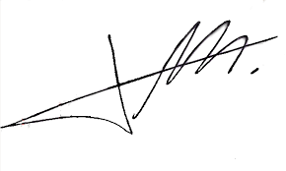
FRCS© NCMP
Clinical Assistant Professor, UBC
Department of Obstetrics and Gynecology SMH

